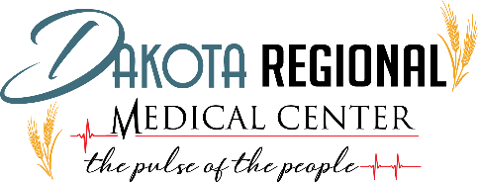

No Surprise Act GFE-Good Faith Estimate
The Dakota Regional Medical Center is committed to follow the guidelines of the Public Health Service Act section 2799B–6, as added by section 112 of division BB of the CAA, requires providers and facilities, upon an individual’s scheduling of items or services, or upon request, to inquire if the individual is enrolled in a health plan or health insurance coverage, and to provide a notification of the good faith estimate of the expected charges for furnishing the scheduled item or service and any items or services reasonably expected to be provided in conjunction with those items and services, including those provided by another provider or facility, with the expected billing and diagnostic codes for these items and services. If the individual is enrolled in a health plan or coverage (and is seeking to have a claim for the item or service submitted to the plan or coverage), the provider must provide this notification to the individual’s plan or coverage. In the case that the individual is not enrolled in a health plan or coverage or does not seek to have a claim for the item or service submitted to the plan or coverage, the provider must provide this notification to the individual.
- The GFE-good faith estimate provided is in regards to the primary concerns when appointment was scheduled. GFE is only an estimate regarding services/items reasonably expected to be furnished and actual services/items or charges may differ.
- There may be additional services/items the provider recommends as part of the course of care that must be scheduled or requested separately and are not included in the attached GFE.
- The individual has the right to initiate the patient-provider dispute resolution process if the actual billed charges are substantially in excess of the expected charges included in the GFE. To inquire information regarding the patient-provider dispute resolution process, please contact Rusti Post at rpost@dakotaregional.com or call (701) 786-1700. By initiating the patient-provider dispute resolution process will not adversely impact the quality of care furnished to you by Dakota Regional Medical Center.
- The GFE is not a contract and does not require you to obtain the service/items form any of the providers listed on the GFE.
We have also included the information regarding our self-pay uninsured payment policy. The payment of $100.00 must be paid at the time of registration. We appreciate our patients and are here to assist with any financial needs you may have. Please call Amber in our Business Office (701)-786-1700 if you have any questions regarding DRMC statement.

